**Introduction:**

The project is about DIU bus schedule using emu8086.

**Objective:**

1. Choose option (1,2,3,4,5,6,7)
2. Go to return menu (Type: R)
3. Exit menu (Type :E)

**Working Procedure:**

When we run the program the main menu will pop-up then we have to choose various option then if we inter any choice of (1,2,3,4,5,6,7) it will show the DIU bus schedule time then when we press ‘R’ it will return to the main menu and when we press ‘E’ it will exit or terminate.

**Code:**

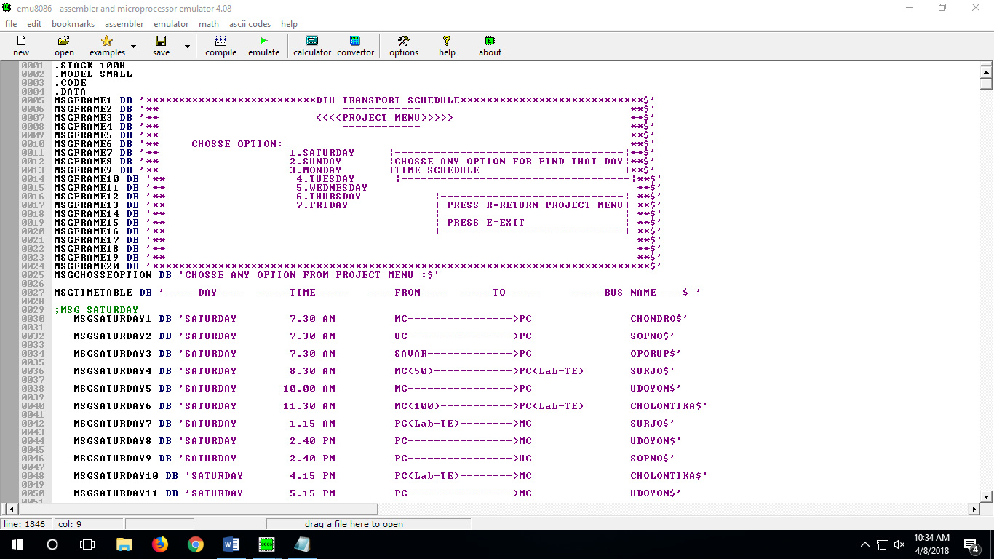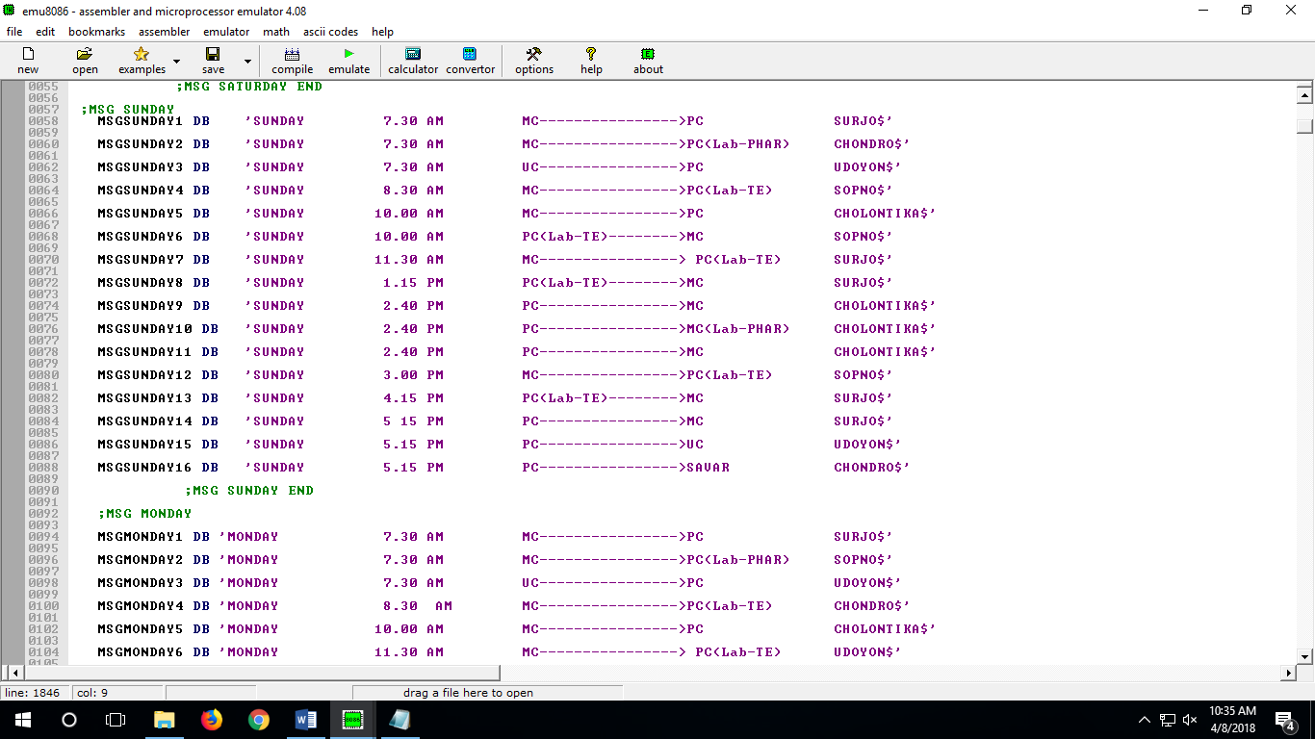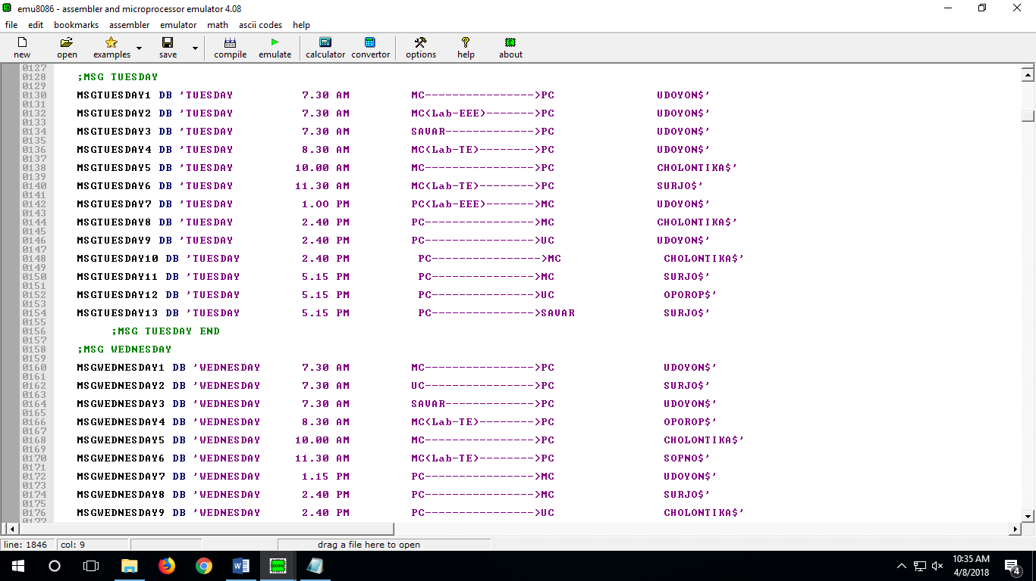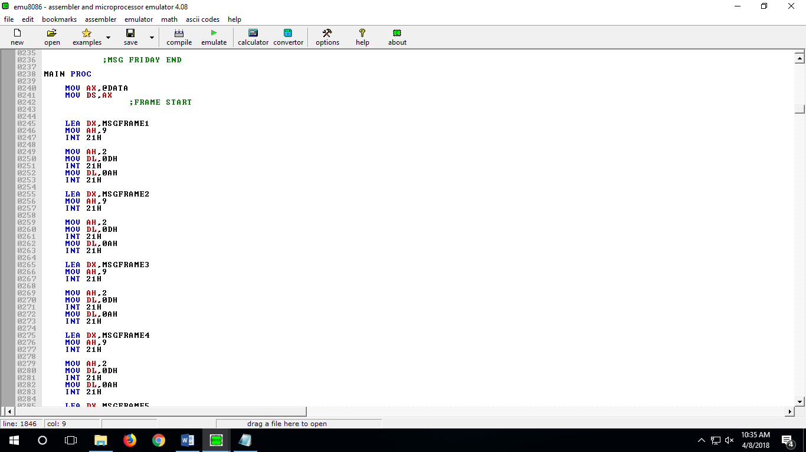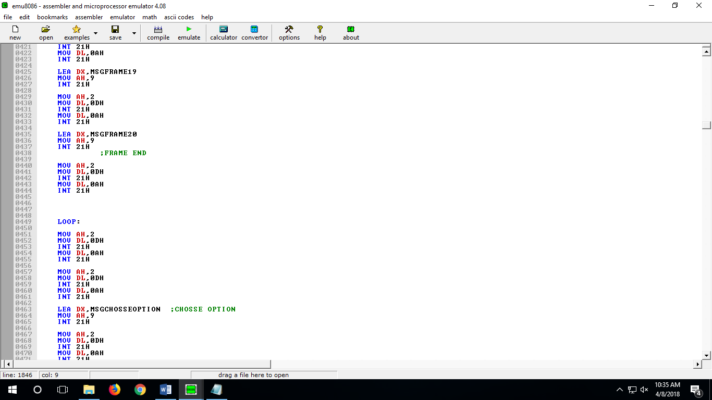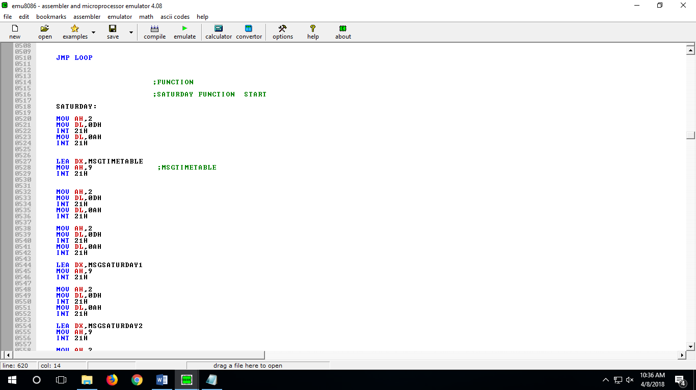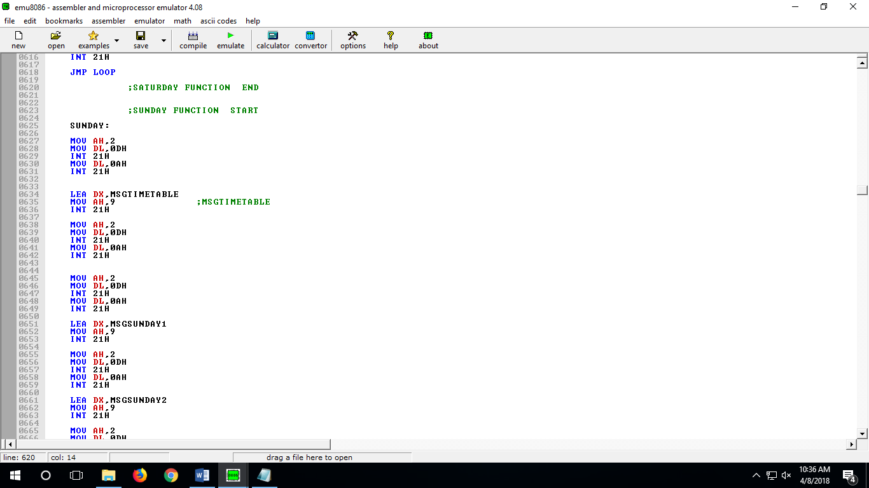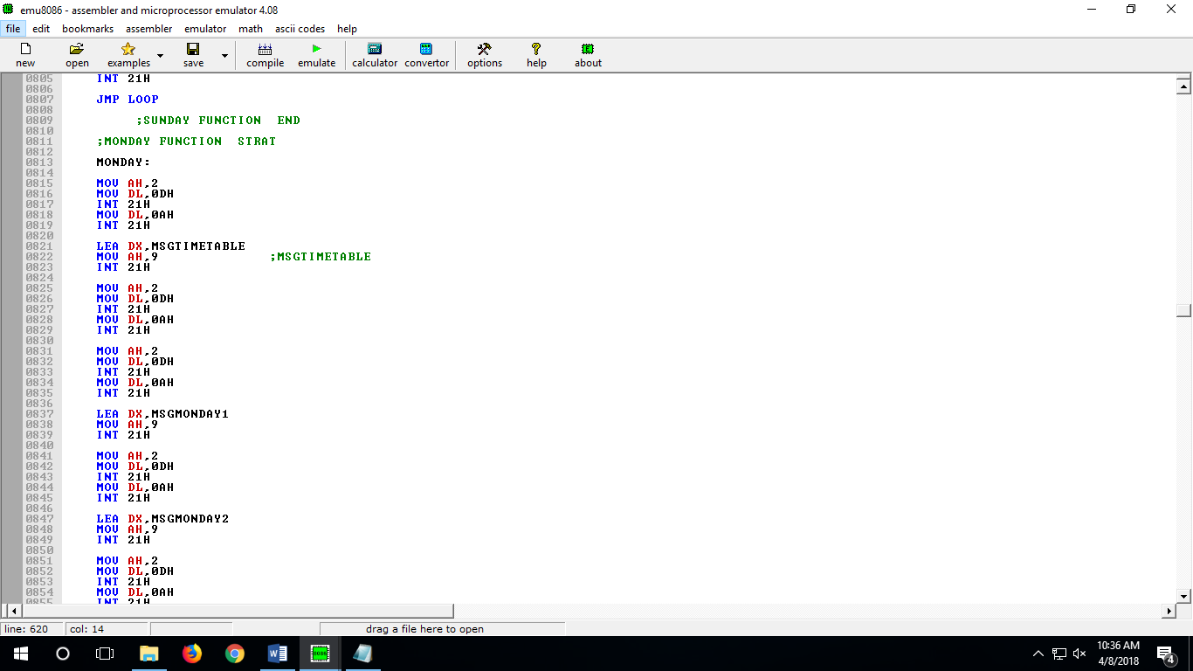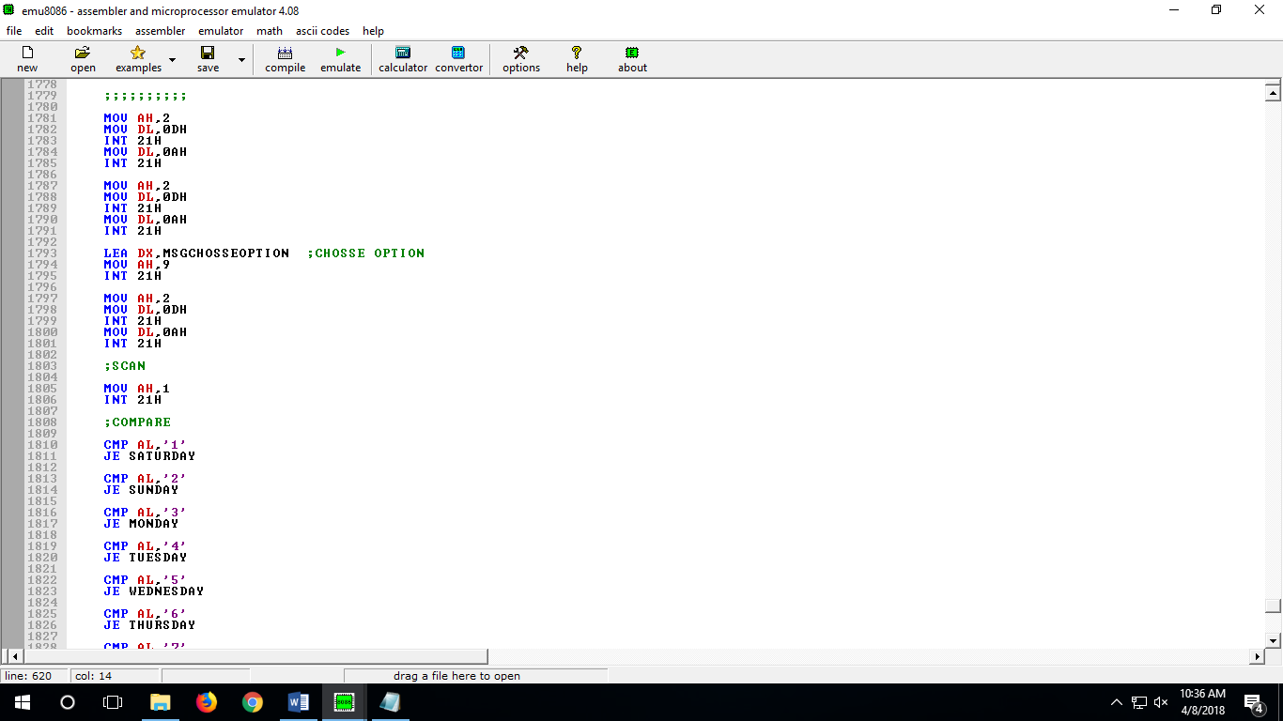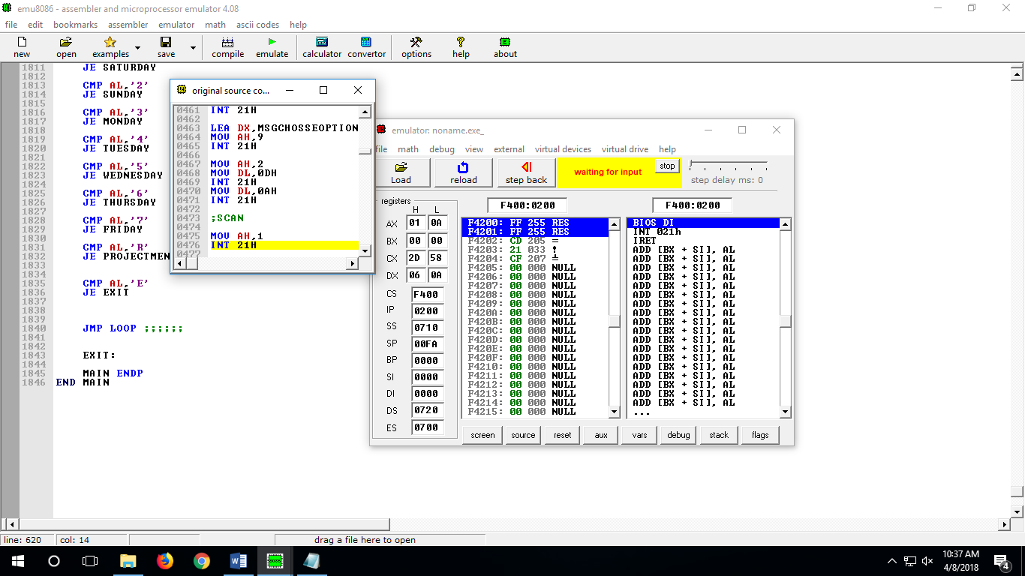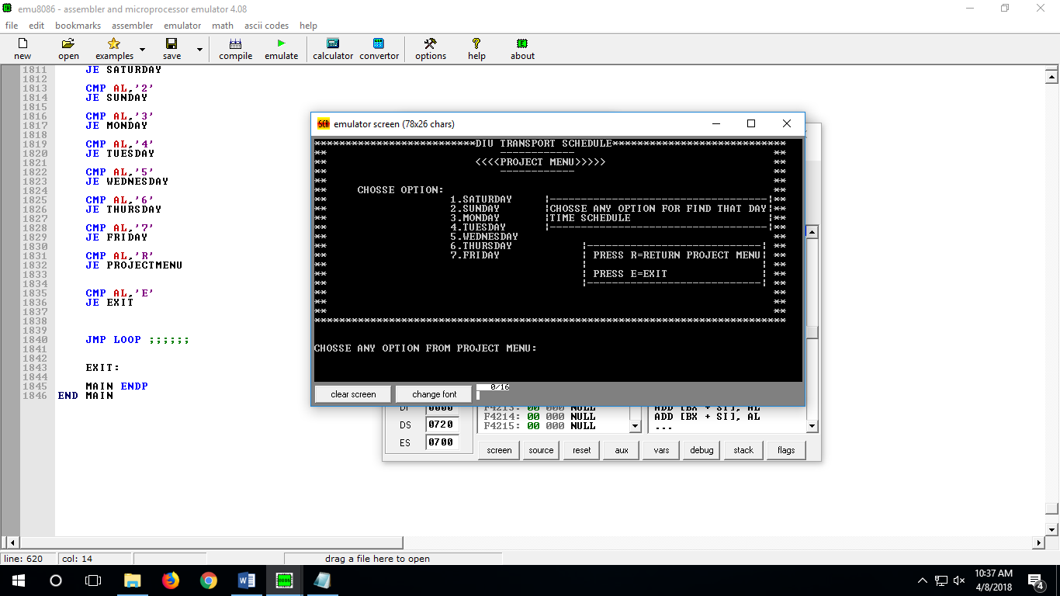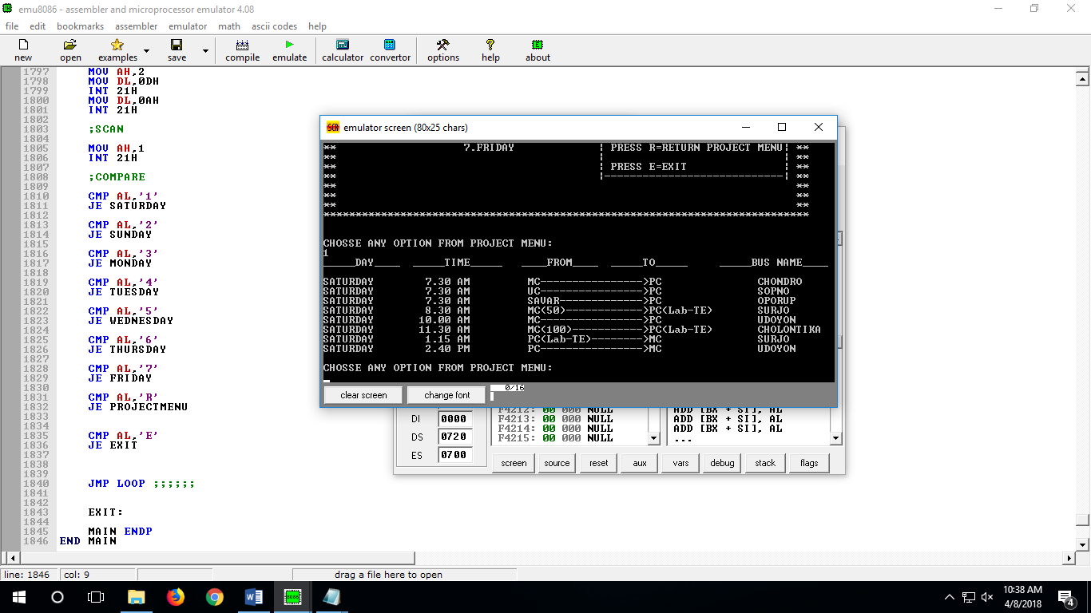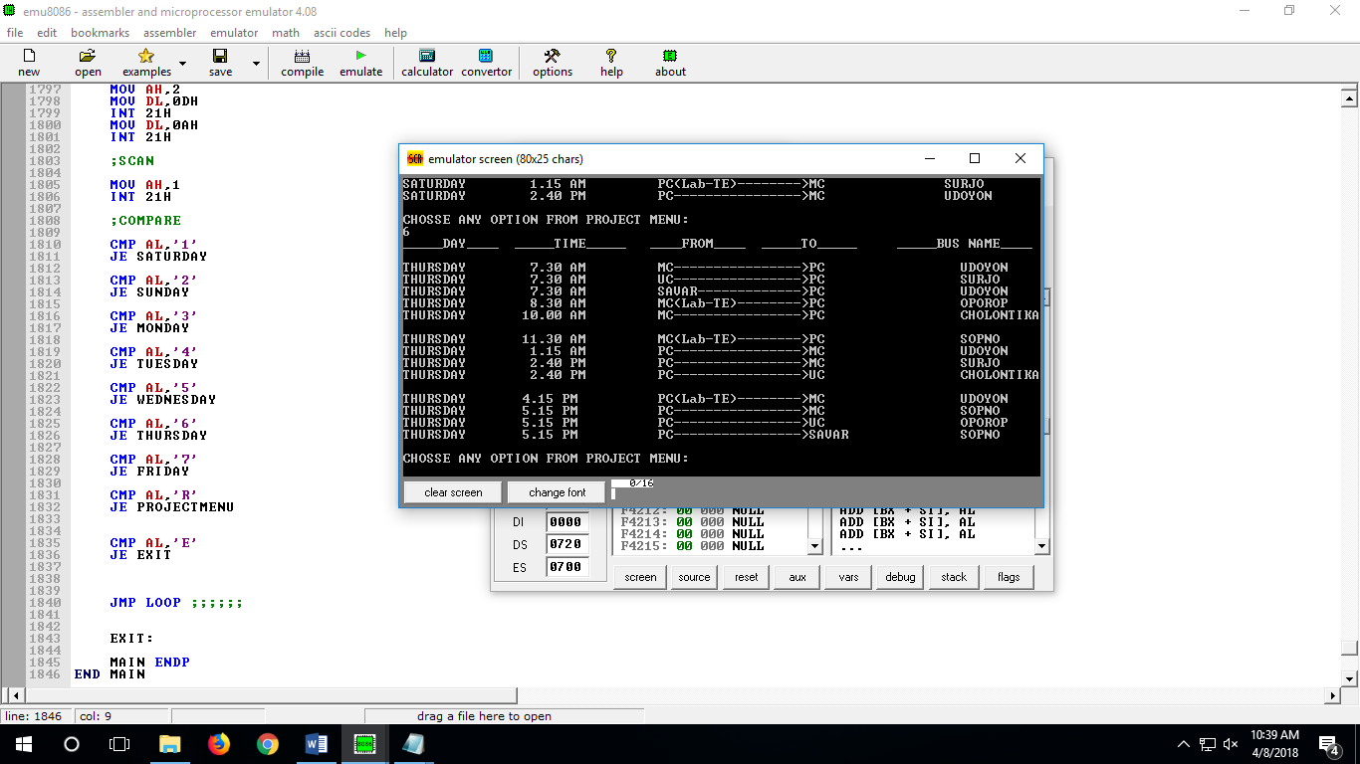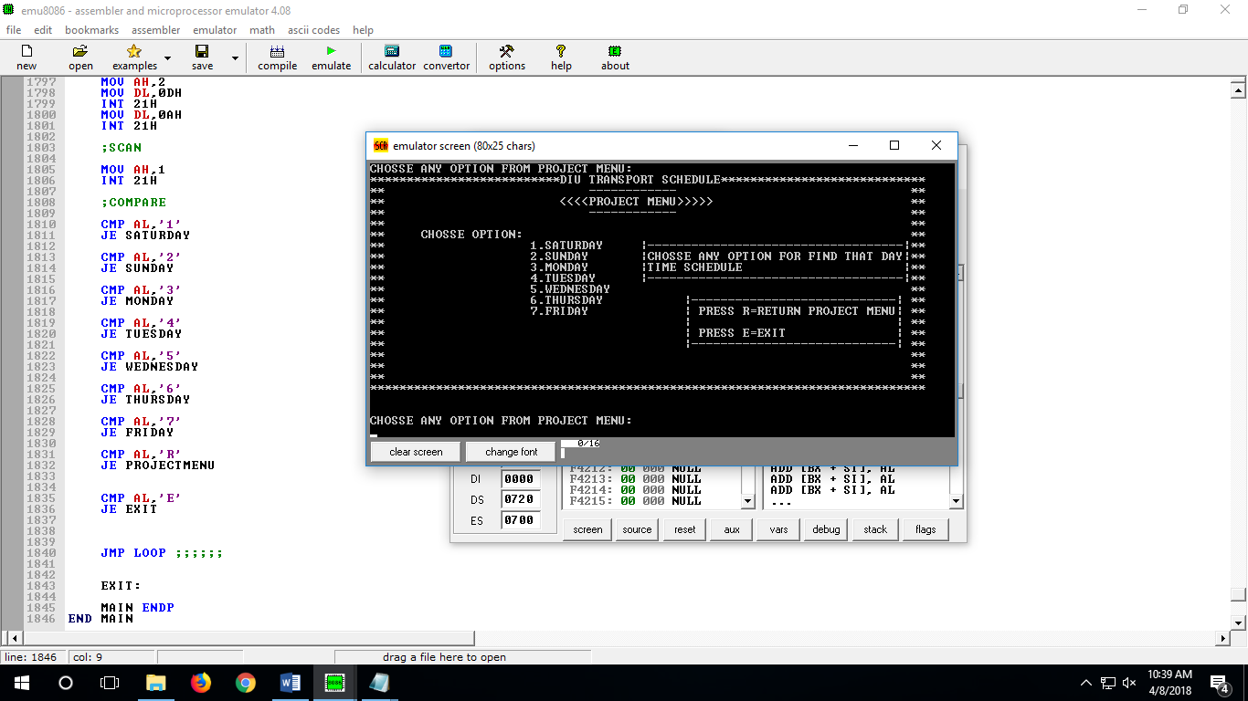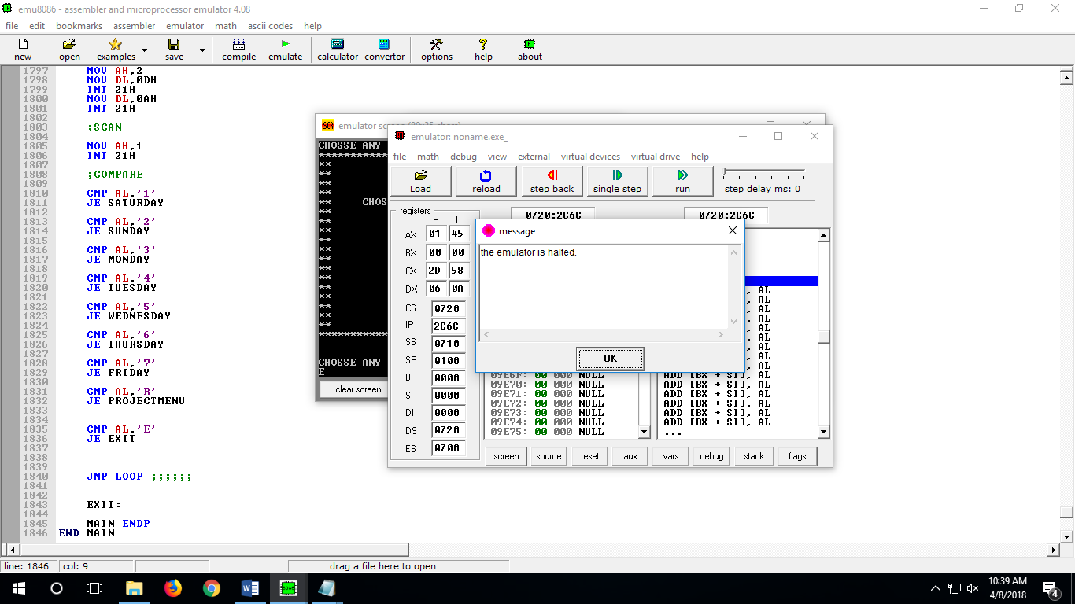

**Conclusion:**

There is a lot more to assembly language than knowing the operation of a handful of machine instructions. You have got to know how to use them and what they can do . Many instructions are useful for operations that have little to do with their schedule or obvious functions .

This program is very handy to use and understandable and its time consuming software .